**Excel Assignment – 14**

Que.1) How much Diamonds were looted from Chennai Port Trust?

Ans. – 7182 ounces.

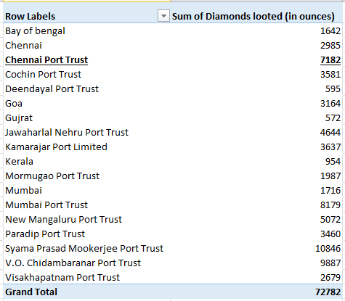

Que.2) How many Ships were looted near Paradip Port Trust and Chennai Port Trust?

Ans. – Ships looted near Chennai Port Trust: 2

Ships looted near Paradip Port Trust: 3

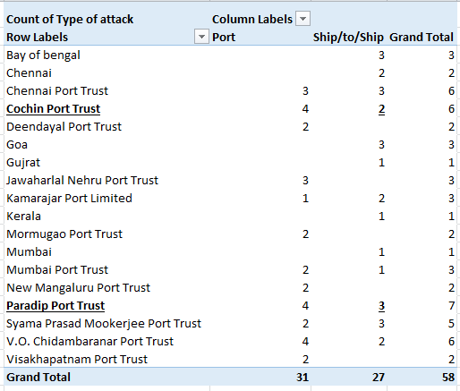

Que.3) What is the sum total of Diamonds looted from the V.O. Chidambarnar port trust?

Ans. – 9887 ounces

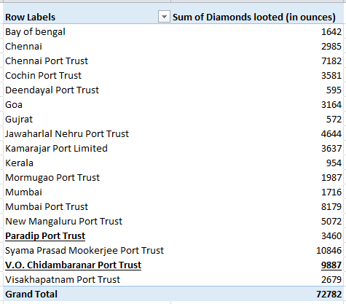

Que.4) What is the average amount of Diamonds and Soft drinks looted?

Ans. – Average amount of Diamonds Looted: 1254.86 ounces.

Average amount of Soft Drinks Looted: 2227.76 gallons.



Que.5) What is the ratio of soft drinks drunk to soft drinks looted?

Ans. – 0.392

